G.Yaswitha
192325087
AIML

1.Floyd’s Algorithm for All-Pairs Shortest Path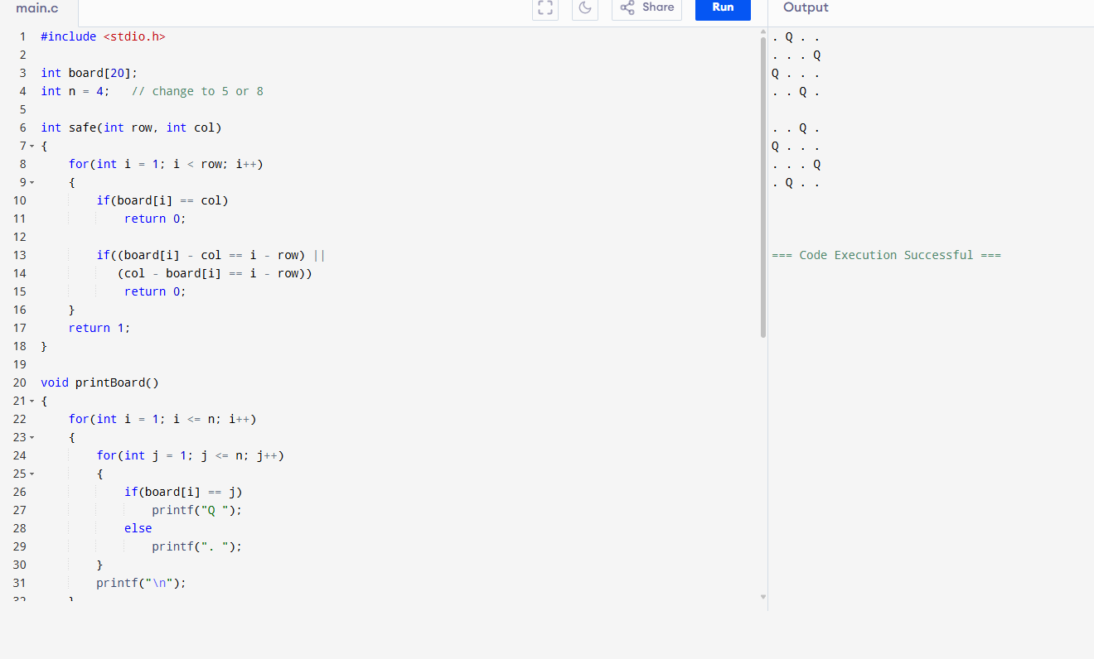
2. Optimal Binary Search Tree (OBST)
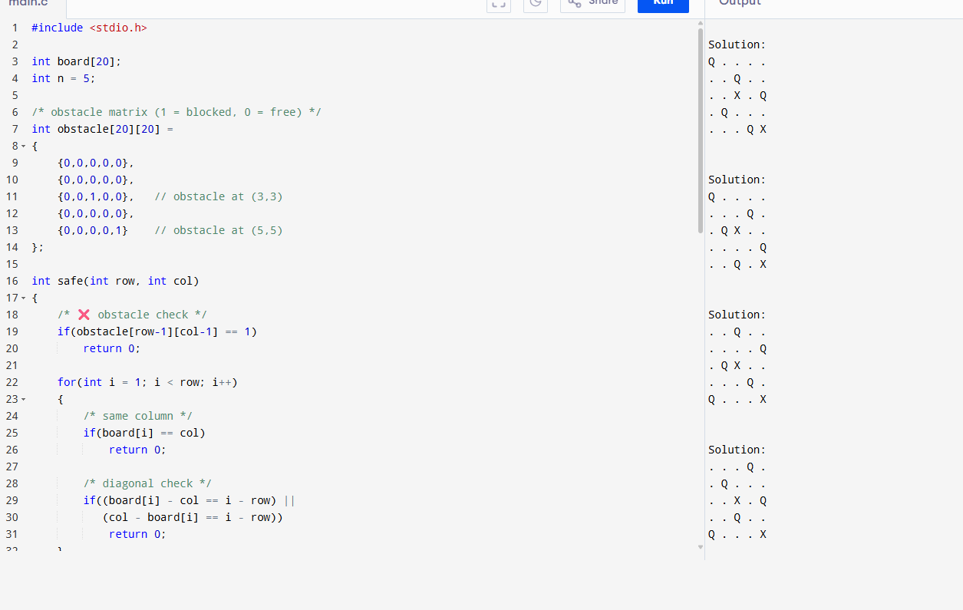

3. Traveling Salesman Problem (TSP) using Dynamic Programming
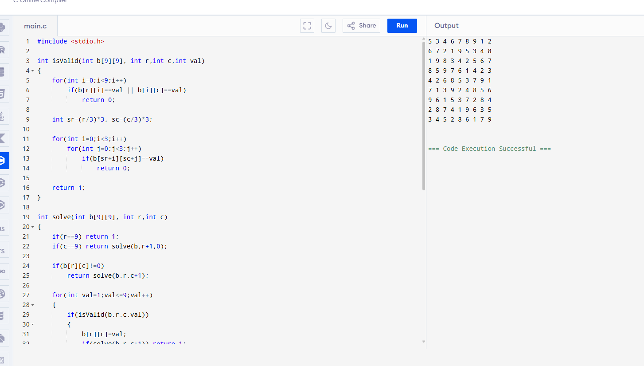
4. Traveling Salesman Problem (TSP) using Dynamic Programming
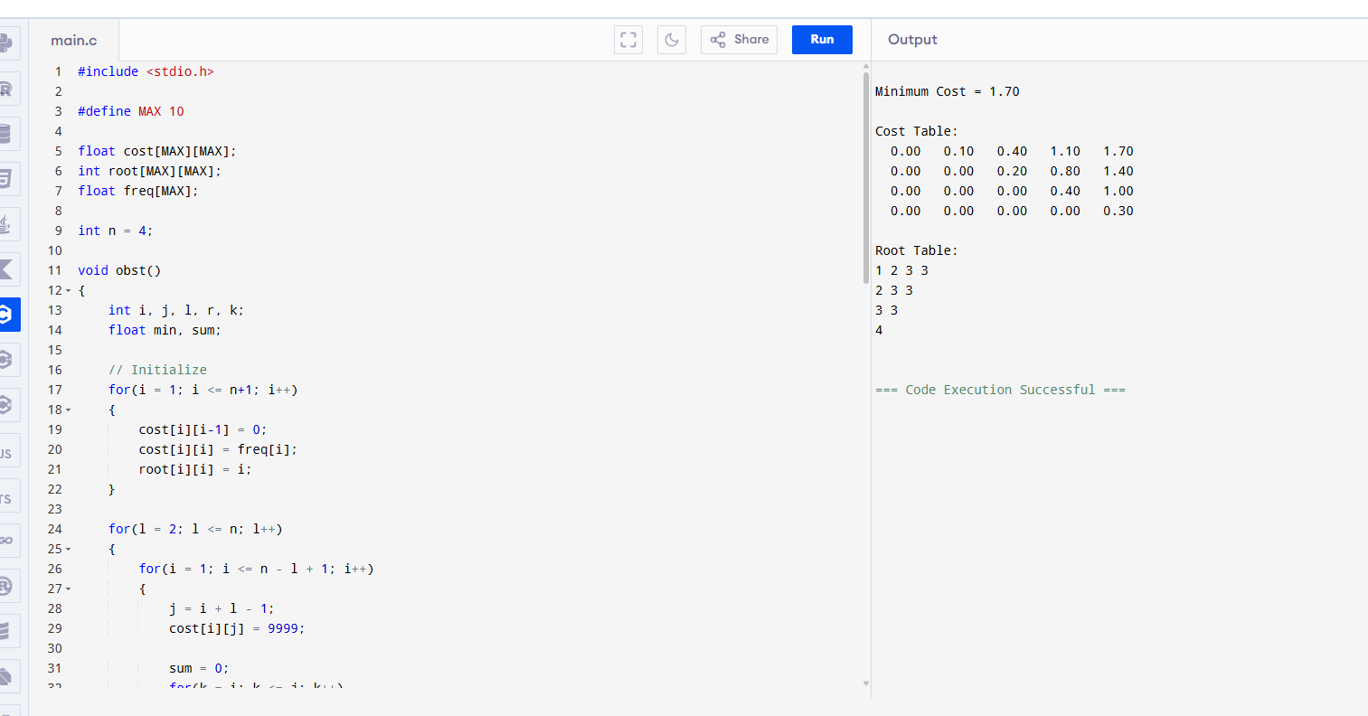
5. Maximum Probability Path in Graph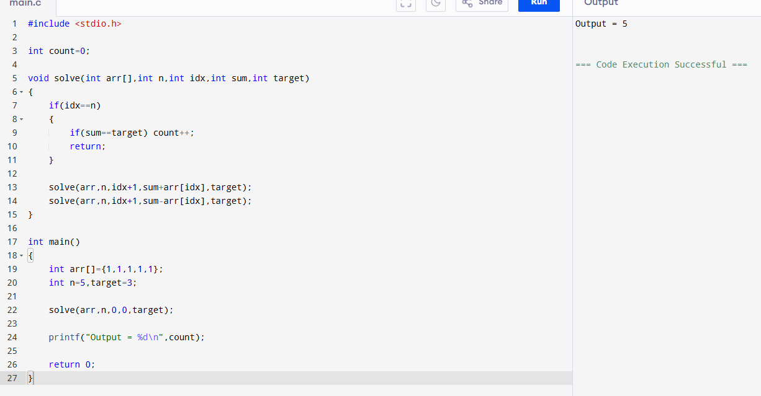
6. Unique Paths in Grid (Dynamic Programming)
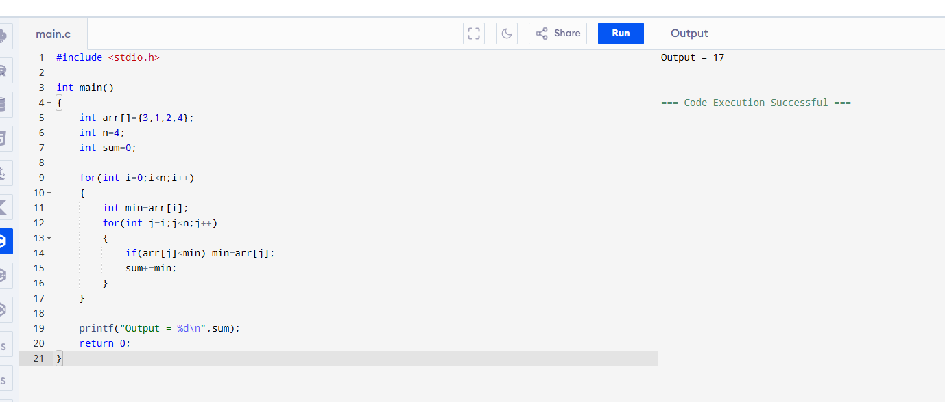

7. Good Pairs in Array88.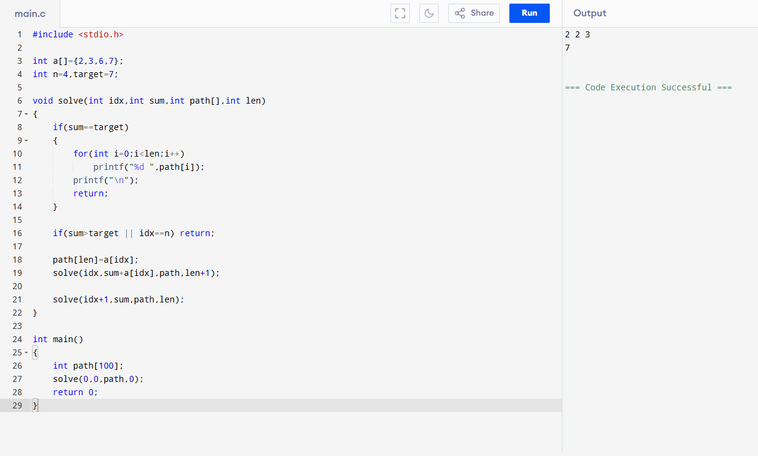

8. Network Delay Time (Dijkstra/Floyd based)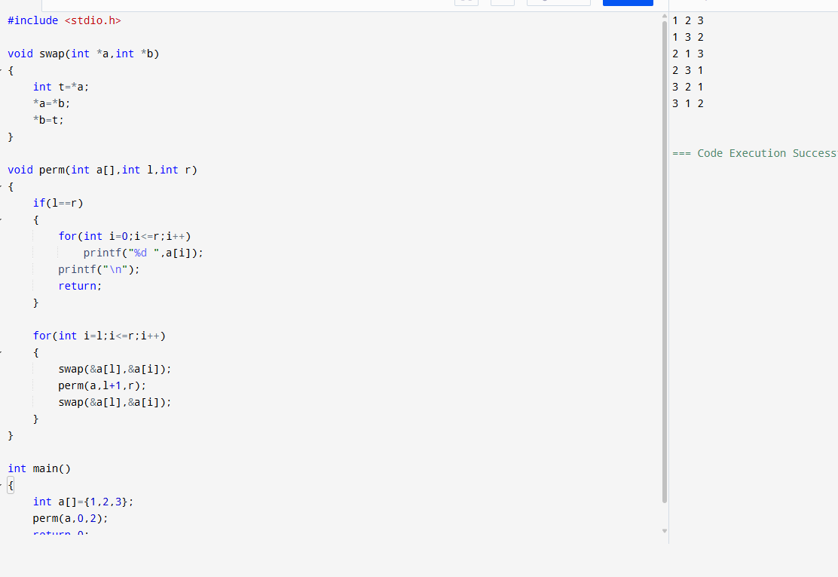

9. Word Break Problem (Dictionary Segmentation)10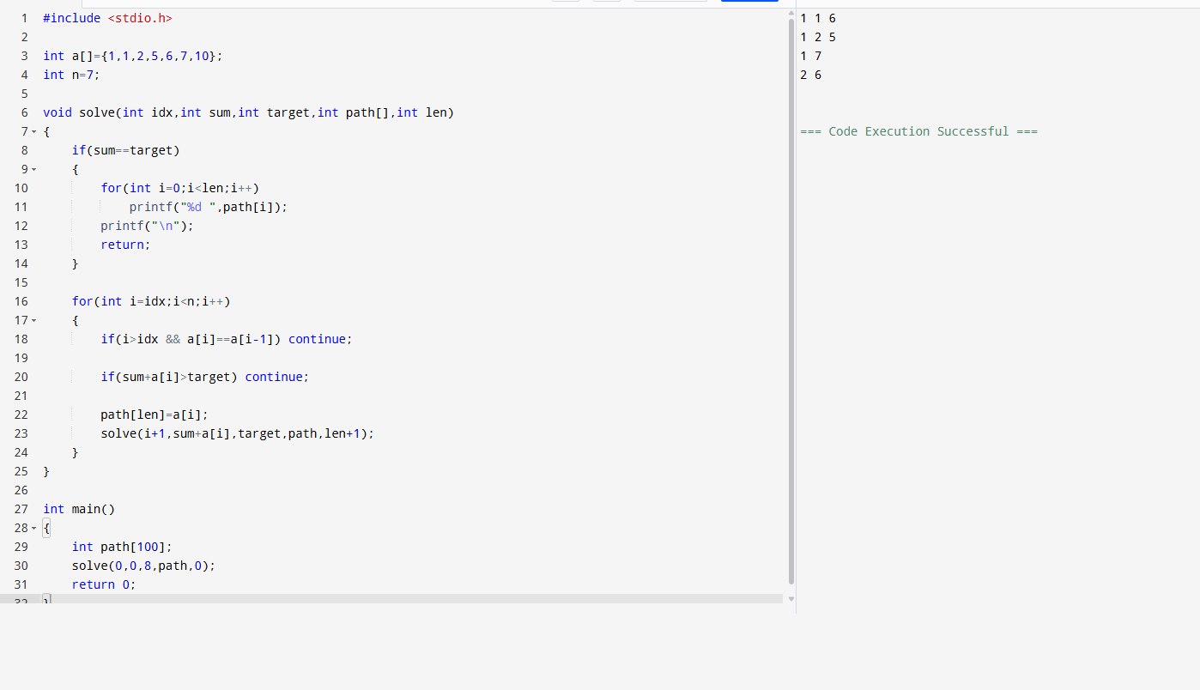
10. Text Justification Problem
